8TH EXPERIMENT
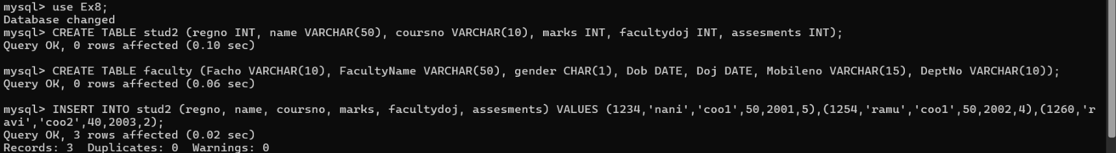
1.
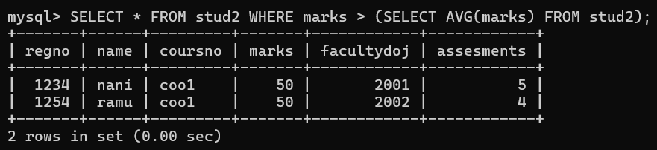

2.
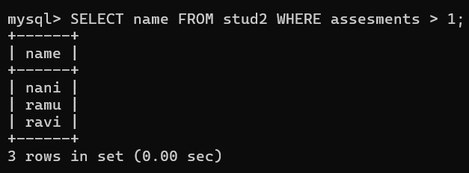

3.
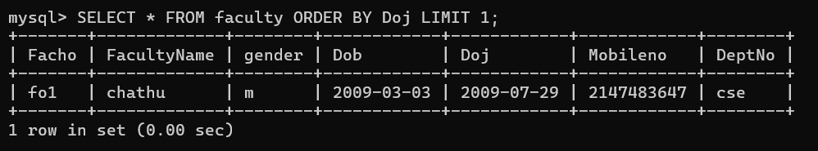

4.
